**Utilizing YOLOv6 Deep Learning Algorithm Trained on Custom Dataset to Accurately Count Sugar Beet Plants within Agricultural Fields**

P. Friedrich1 & G. Schimmer1

*1 M.Sc. Geography Student at Heidelberg University*

**Contact**

philipp.friedrich@stud.uni-heidelberg.de

gustav.schimmer@stud.uni-heidelberg.de

**Keywords:** *Sugar beet, Bifoliate growth stage, Deep learning, YOLOv6, Object detection, Agriculture, Crop science, Crop monitoring, Photogrammetry*

**Abstract**

The following paper provides insight into the idea of detecting sugar beet plants in photos. The basis of our research is that for a sugar beet farm, it is necessary to count how many plants are present in one's own field to plan potential replanting and calculate the projected earnings from said field. The conventional method of these counts is simple but time-consuming. In this approach, a certain percentage of the cultivated field is chosen, and the number of healthy plants in the two-leaf stage is simply counted. This number is then extrapolated to the entire field.

To improve this time-consuming counting process, we have developed the approach under investigation here, utilizing drones or smartphone images. Under the right conditions, this method aims not only to count a small portion of the plants in an entire field but all the plants in the field. This allows for a much more accurate determination of the number of plants in the two-leaf stage compared to interpolating the conventional method. Furthermore, the method we developed could enable very precise dosing and thus a more economical use of pesticides.

To recognize the plants in the drone or smartphone images, we use a self-trained YOLOv6 model, which is intended to produce the required results.

1. **Introduction**

Add text here.

1. **Data & Methods**

IMAGE STUDY AREA

* 1. **Study area and data acquisition**

The images utilized in this study were captured on an agricultural field located near the city of Würzburg in Bavaria. The field was cultivated with sugar beets during the year 2023, and the sowing process occurred on April 13, 2023. Throughout the entire field, covering an expansive area of 6.4 hectares, images were obtained from two distinct study areas, each spanning approximately 7.5 square meters and 5 rows of crops. Image acquisition occurred at various time steps throughout the growing period. Figure X provides an overview of the specific locations. The entire area surrounding the two sites is intensively cultivated, with winter wheat being the predominant crop. Additionally, corn, sugar beets, canola, and spelt are also cultivated in the region. The average annual precipitation amount for the climate normal period from 1981 to 2010, as recorded at the Würzburg climate station, is 596.1 millimeters. The peak of precipitation occurs in July, while the minimum is observed in September (DWD, 2022).

The images were manually captured using a Huawei P30 Lite smartphone and a standard selfie stick. The smartphone was positioned at an approximate height of 100 centimeters, resulting in an image footprint of 2x1 meter and a ground sampling distance (GSD) of 0.5 millimeters. For each time step, up to 120 images were taken at each study site, with an overlap ranging from 50% to 75%. For the model training, only images captured on May 14, 2023, were used, as the algorithm is primarily intended to recognize and count sugar beet plants in the earliest stages. The mentioned date was the earliest possible with available images. At this time the individual plants were predominantly in the four-leaf stage (Figure X).

* 1. **Methods**

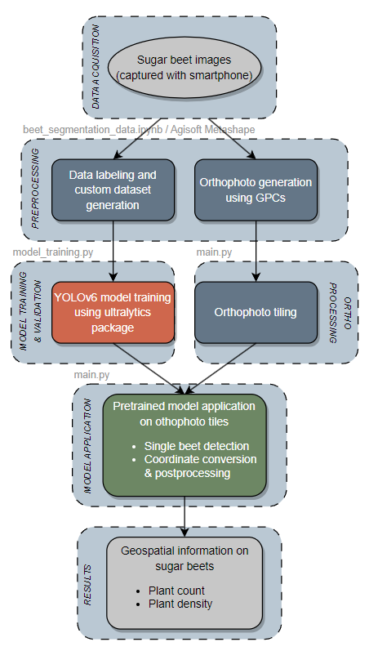

Data preparation and preprocessing

Data preprocessing here?

To train a model, a substantial dataset of labeled images is essential. In this instance, labels for individual sugar beet plants were required. These image labels were manually generated using the open-source and freely available web application Alpha Make Sense (makesense.ai). This tool provides output file formats compatible with the YOLOv6 model. Both the images and labels are utilized in the subsequent model training process.

Resolution testing:

To expedite computational time, streamline processing steps, and enhance overall efficiency, we endeavored to reduce the original image resolution of 4000x3000 pixels. Consequently, we resampled the images to explore whether employing lower resolutions significantly impacted the model's accuracy. Ultimately, we opted for the intermediate resolution among those examined, as it appeared to strike the best compromise between accuracy and processing speed. The final resolution chosen was 2000x1500 pixels per image. To achieve this resolution, we utilized the "resize" function from the cv2 package.

Another resolution tested, depicted in the figure (??????), was 1000x750 pixels. However, this resolution proved to be a substantial degradation of image quality, as evident in the figure (??????). Notably, the edges of the sugar beet leaves are no longer distinctly delineated, and this observation was further substantiated by a decline in model training performance.



1. **Results**

IMAGE PLANT POINTS

IMAGE CONFUSION MATRIX

TABLE OF VALIDATION SCORES

Present notebooks and program.

Show some images of detected plants.

Present performance measures.

Show model results on orthophoto and counting result.

1. **Discussion**

EVTL IMAGE RESOLUTION (see Method)

EVTL WEED DETECTION

No possibility to check on other data (e.g. drone data, different weather conditions or regions). Overfitting?

Limitation of the model to decide between sugar beet and no sugar beet, weeds might cause trouble.

Pretty basic model and approach but already usable in practice.

1. **Conclusion**

Add text here.

**Acknowledgements**

Acknowledgements of support for the project/paper/author are welcome. Note, however, that for the paper to be submitted for review all acknowledgements must be anonymized.

**References**

Chan, K.L., Qin K., 2017: Biomass burning related pollution and their contributions to the local air quality in Hong Kong. *Int. Arch. Photogramm. Remote Sens. Spatial Inf. Sci*., XLII-2/W7, 29-36. doi.org/10.5194/isprs-archives-XLII-2-W7-29-2017.

**Appendix**

Any additional supporting data may be appended, provided the paper does not exceed the limits given above.